Bio clim PCA

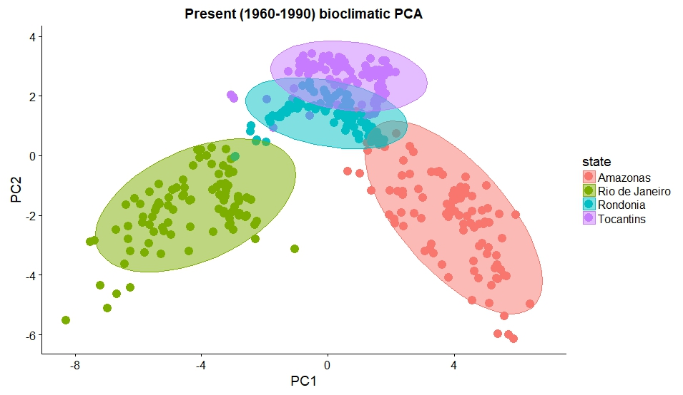

Present- Overlap between rondonia and Tocantins (same latitude), Amazonas and Rio furthest apart  
PC1= 53.323, PC2=26.792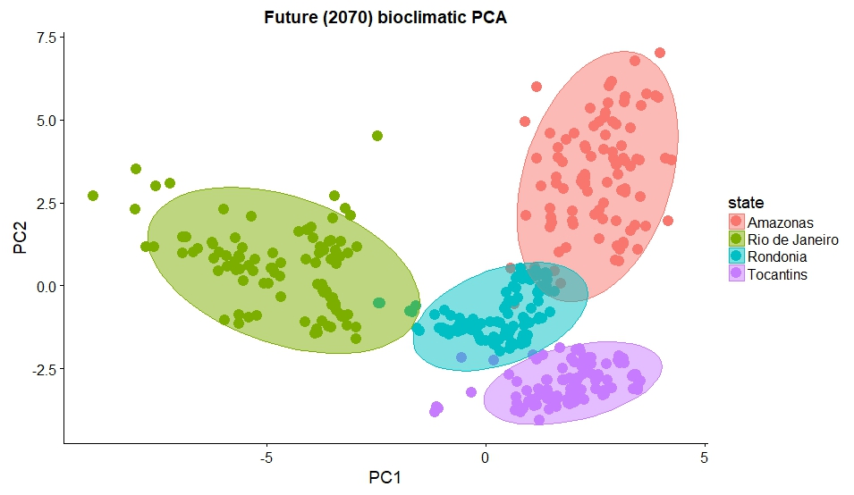

Future- More overlap within Amazon biome (Rondonia, Amazonas), more distinct  
PC1= 48.083, PC2=33.190

Brazil map- <https://downloads.ibge.gov.br/downloads_geociencias.htm>

Bio clim variables- 2070- <http://www.worldclim.org/cmip5_30s>

1960-1990- <http://www.worldclim.org/current>